**AI Enemy**

**Walk on path (Patrolling Guard)**

<https://www.youtube.com/watch?v=zNJEvAGiw7w&list=PL4G2bSPE_8ukuajpXPlAE47Yez7EAyKMu>

1. Next thing we are going to do is make the AI walk on a path determined by us.
2. Let's move all the previous Behaviour Tree aside and disconnect
3. We need a new Actor that can store vectors for the patrol path.
4. For that create a new Actor class and name it PatrolPath.
5. Open it and add a variable of type vector and make it an array.
6. Make instance editable and check ‘Show 3D widget’
7. 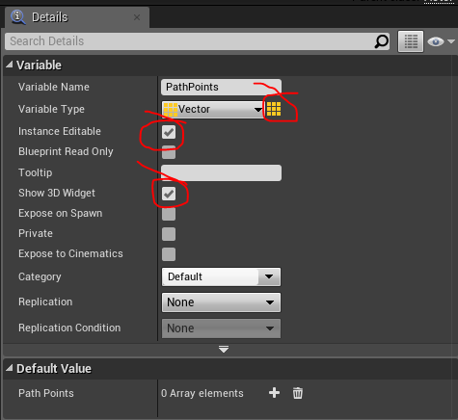
8. Drag and drop the actor in the level and while it is selected on details panel add elements. You can select the 3D representation of the vector in level and move it.
9. 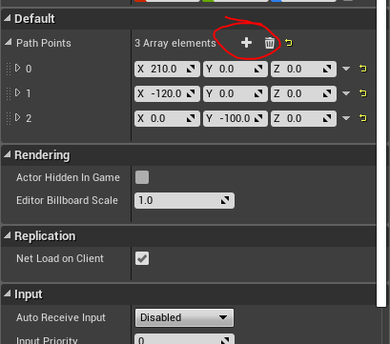
10. 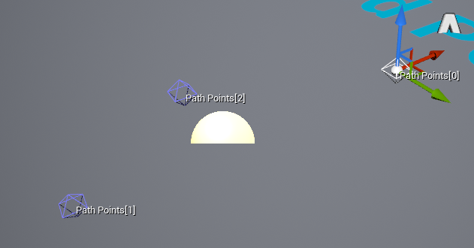
11. Place the points in different places in the world.
12. Now go to the Enemy Character and and make a variable of type PatrolPath object reference (actor we just created.)
13. Make the variable instance editable. Compile and save.
14. Now go to the world and select the Enemy Character. On its details panel we should be able to select the PatrolPath actor.
15. Now we need to pick each point using BP
16. So go to BB and create 2 variables PatrolPathVector and PatrolPathIndex
17. Go to BT and add 2 new task and go to content browser and rename it “FindPathPoint” and “IncrementPathIndex”.
18. FindPathPoint will find the location of the path point in the array and set its location to for the character to move. And Increment path Index will increment the index value
19. Add both tasks to the Behaviour Tree
20. 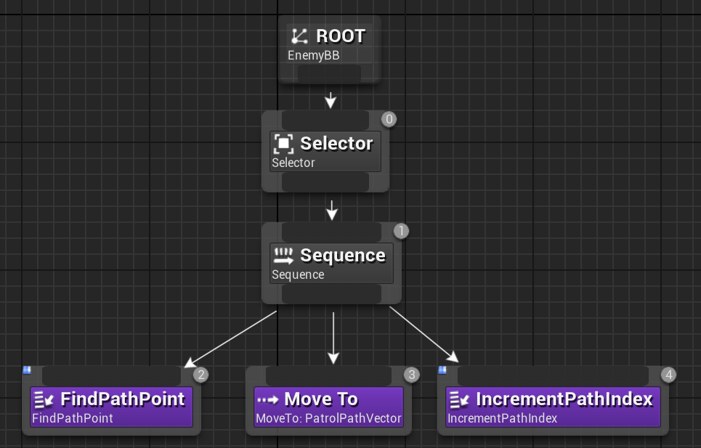
21. Open FindPathPoint
22. Add 2 variables of the type BlackboardKeySelector name it BBPathVector and BBPathIndex
23. Then add the following BP
24. 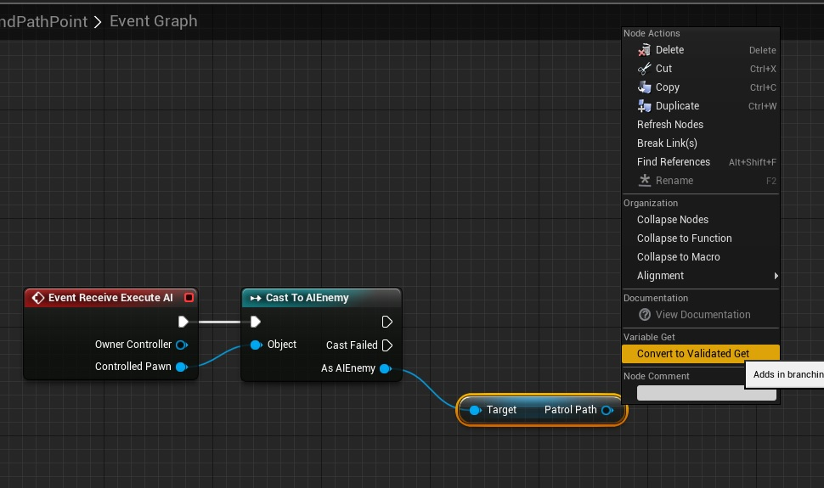
25. Right Click on get node and choose convert to validate get.
26. 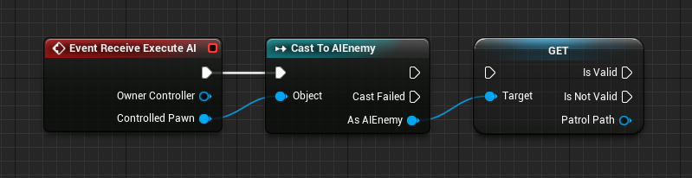
27. This is to ensure that code runs only if an actor path is selected in the character.
28. Now we need to get the location of PathPoint variables in PatrolPath actor in the AIEnemy and assign it to the vector in BB. So add the following BP
29. 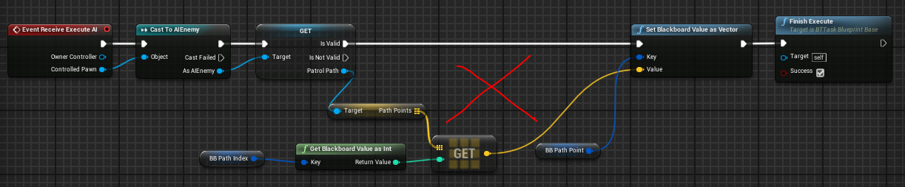
30. We cannot assign the vector value directly because the vector value of the path vectors are in local space not in world space.
31. To overcome this, we can use “TransformLocation” Node.
32. So we need to modify the script as follows.
33. 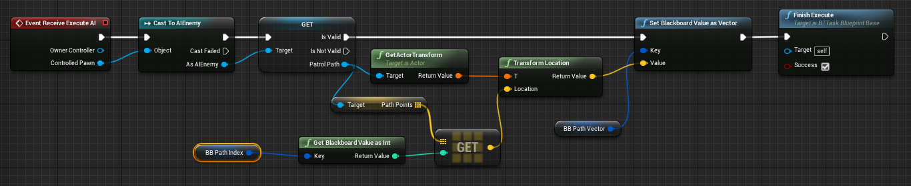
34. This will set the location for enemy character to walk taken from the PathPoint array. Now we need to increment the array index using the next task BP.
35. Open IncrementPathIndex.
36. Add a variable called BB_PathIndex of the type BlackBoardKeySelector (Instance Editable)
37. Add the following BP
38. 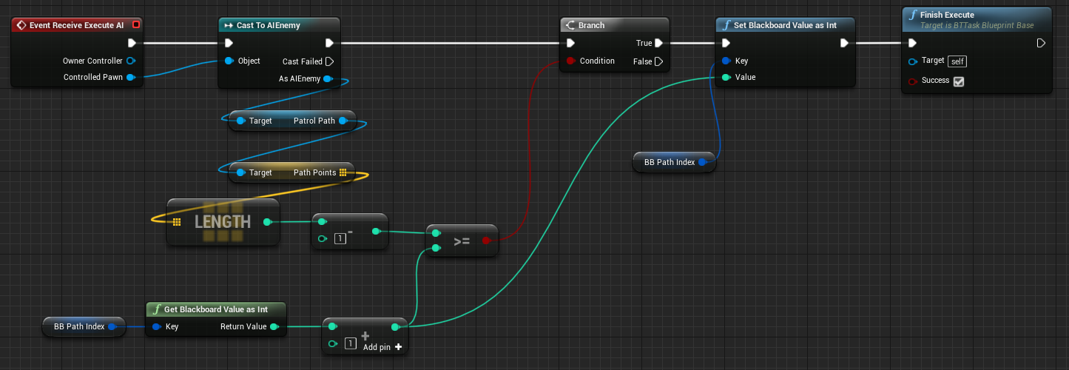
39. In BT select each task and pick appropriate variables in details.
40. 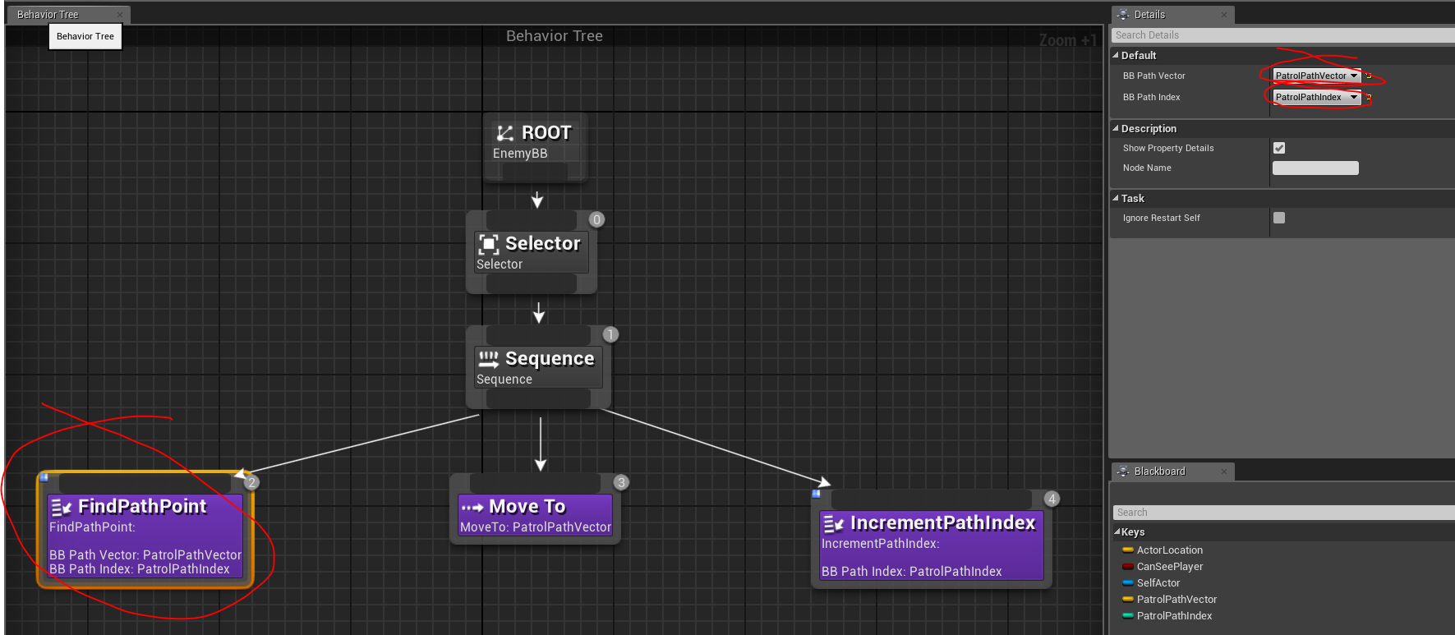
41. 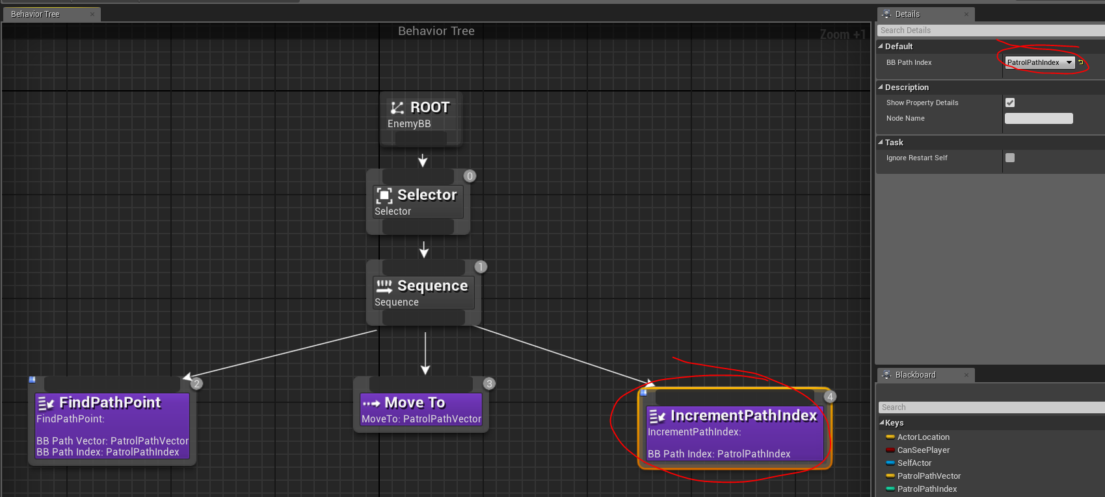

Exercise :

1. Now the enemy stops at the last point you can try to reset the path index in the script so that the character always walks or runs.
2. Select the path vectors randomly.